**SUMMITED TO:**

Lab Manual of Assembly Language Programs

**SIR MUHAMAD ASIM**

**SUMMITED BY:**

**BASIT ALI**

**REGISTRATION NO:**

**S23BSCS012**

**DEPARTMENT:**

**COMPUTER SECIENCE**

**SECTION:**

**A**

**Table of Content:**

|  |  |  |
| --- | --- | --- |
| **Lab-No** | **Questions/Program** | **Page. No** |
| 1. | Write an assembly program to show a string on screen | 3 |
| 2. | Write an assembly program to print a string in a sequence | 4 |
| 3. | Write an assembly program to add two numbers | 5 |
| 4. | Write an assembly program to subtract two numbers | 6 |
| 5 | Write an assembly program to multiply of tow numbers | 7 |
| 6. | Write a program to display the string for specific time on the screen. | 8 |
| 7. | Print 0 to 9 number with the help of iteration or loop | 9 |
| 8. | Write an assembly program about an array. | 10 |
| 9. | Write an assembly program to set your name as a password | 11 |
| 10. | Write an assembly program to half pyramid using nested loop up to down | 12 |
| 11. | Write an assembly program to half pyramid using nested loop down to up | 13 |
| 12. | Write a program that convert a upper case into a lower case | 14 |
| 13. | Write a program that convert a lower case into an upper case | 15 |
| 14. | Write a program that perform the concept of nested loop | 16 |
| 15. | Write a program that print reversed name by using the concept of stack | 17 |
| 16. | Write an assembly program to make a user define procedure of newline | 18 |
| 17. | Write an assembly program using macro | 19 |

Lab Task 01

Write a program in Assembly language to display the name of student?

Program:

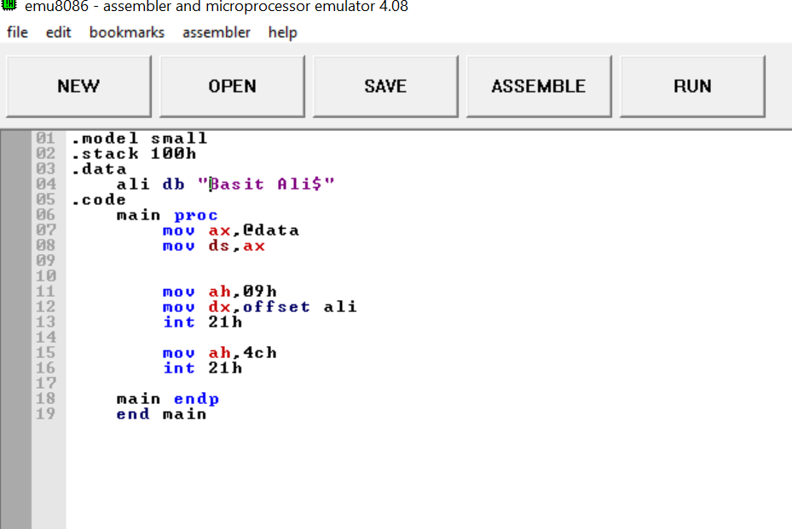

Summary:

This code displays the name of any person. In this code we display “Basit Ali”. “Basit Ali” act string type on the screen and terminate the program.

Output of the program: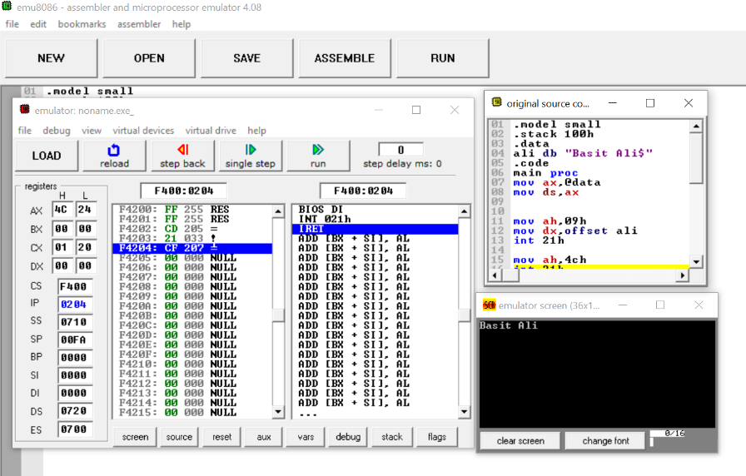

Lab Task 2

Write a program in Assembly language to print any string on screen as a sequence of character?

Program:

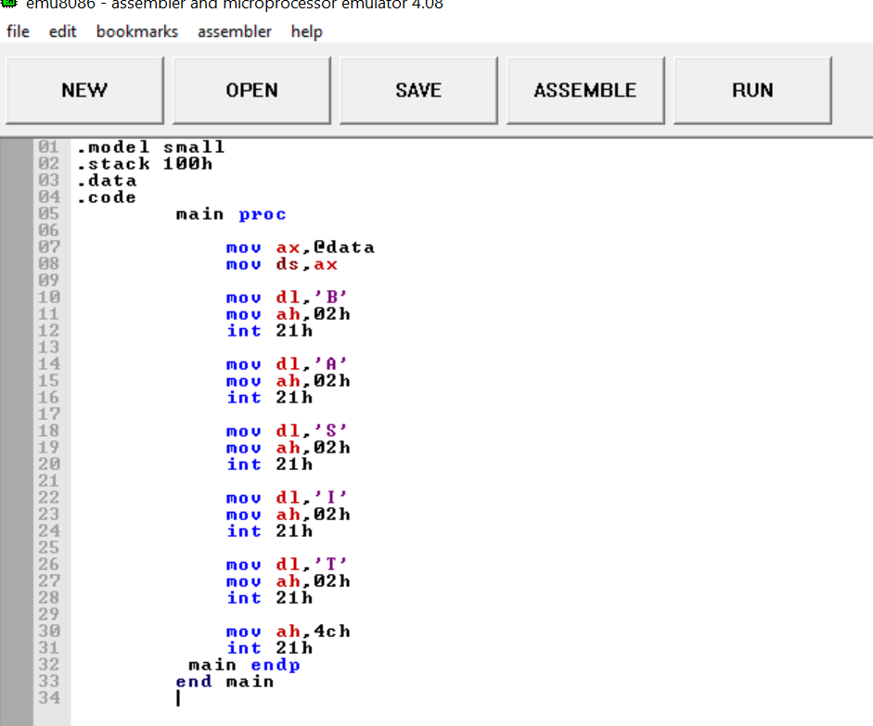

Summary:

In this program we display a string type name but in sequence. So each letter of the name consists as a type of character. In this program we learnt that how a character type is display in the assembly language without taking input from user.

Output of the program:

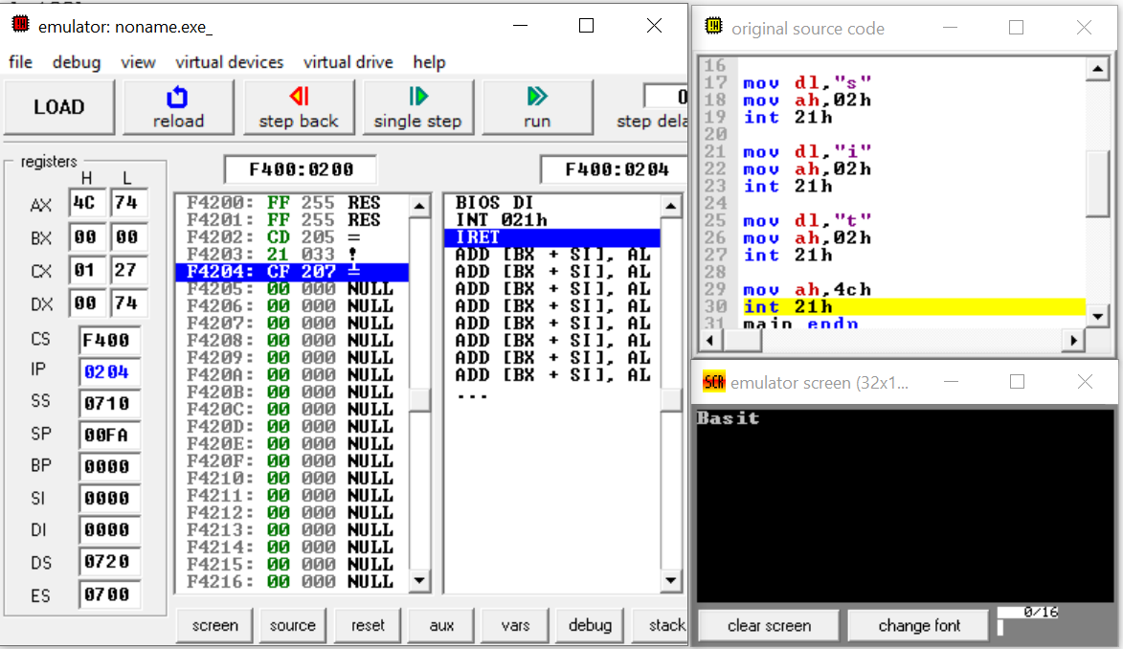

Lab Task 03

Write a program in Assembly Language to add any two number?

Program:

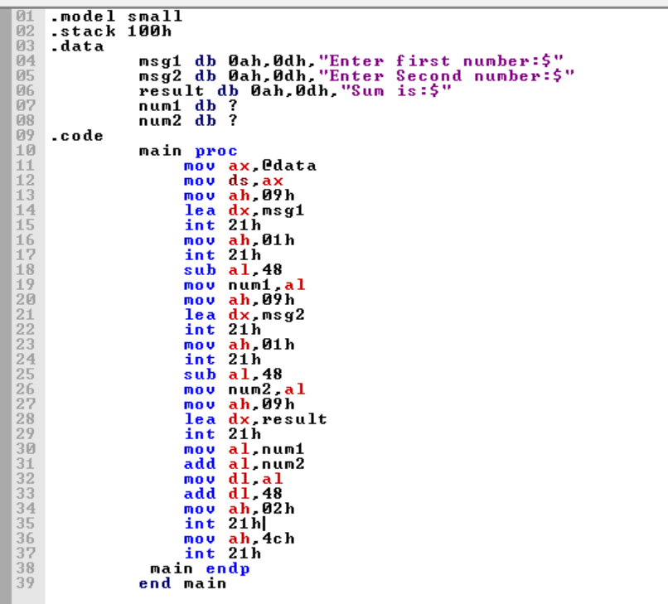

Summary:

In this program we print output of the two number when the number is adding with each other. The two number is taken from user. In this program we teach that how we take a valve from user and how to add two number in assembly language.

Output of the Program:

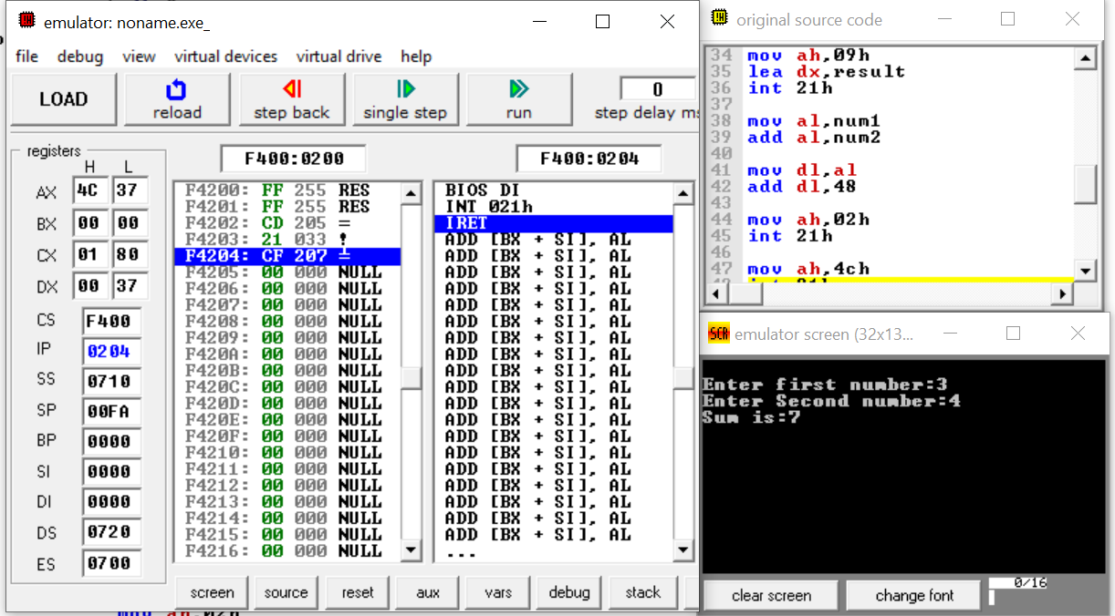

Lab Task 04

Write a program in Assembly Language to subtract any two number?

Program:

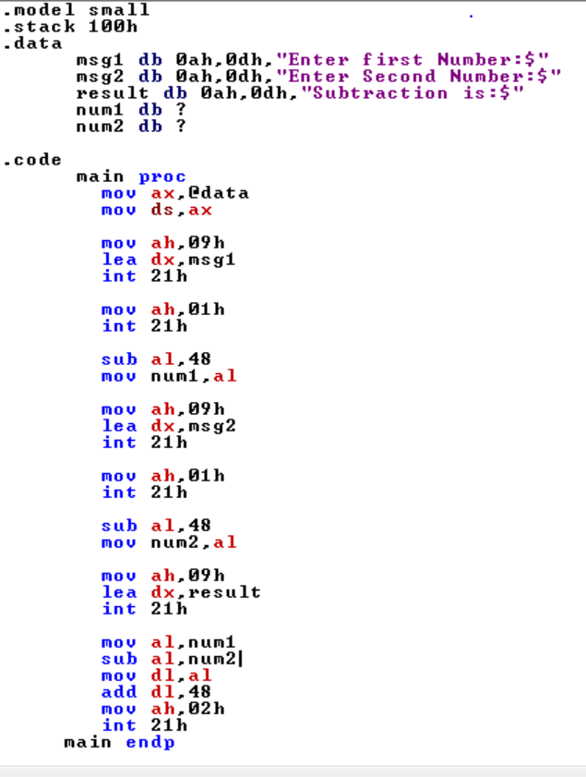

Summary:

In this program we print output of the two number when the number is subtracting with each other. The two number is taken from user. In this program we teach that how we take a valve from user and how to subtract two number in assembly language.

Output of the Program:

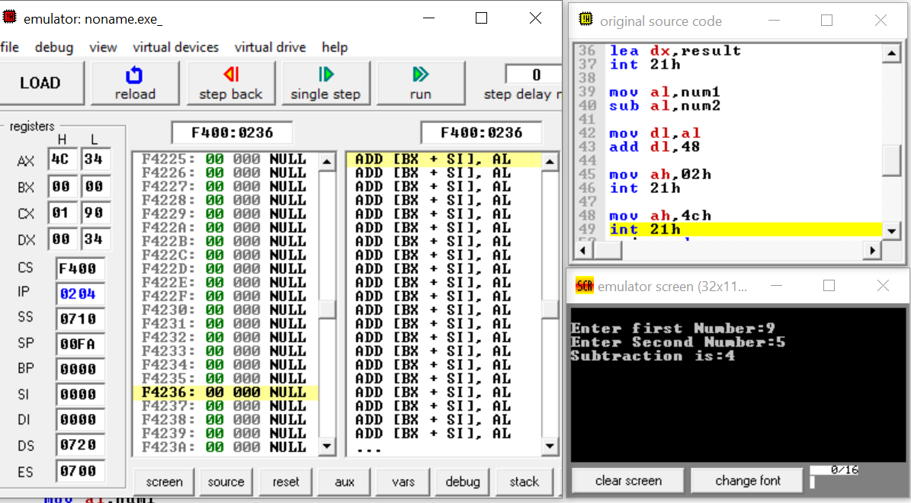

Lab Task 05

Write a program in Assembly Language to multiply any two number?

Program:

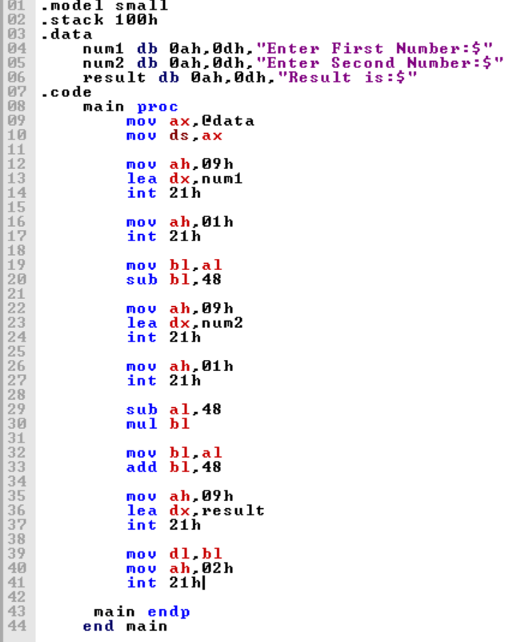

Summary:

In this program we print output of the two number when the number is multiplying with each other. The two number is taken from user. In this program we teach that how we take a valve from user and how to multiply two number in assembly language.

Output of the Program:

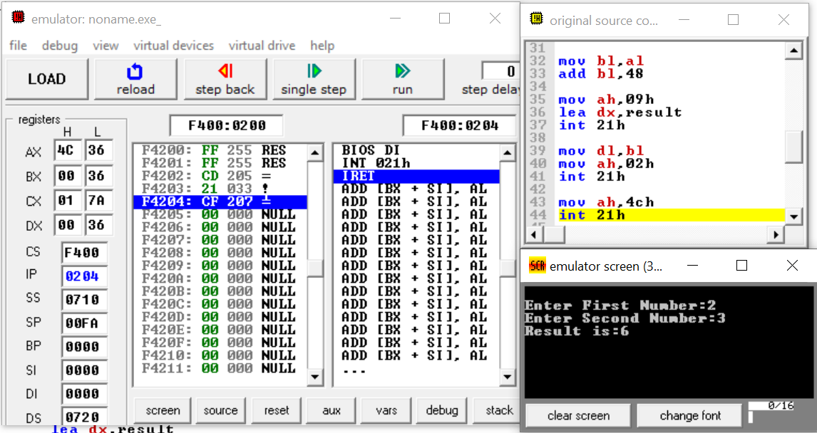

Lab Task 06

Write a program in assembly language to display the string for specific time on the screen.

Program:

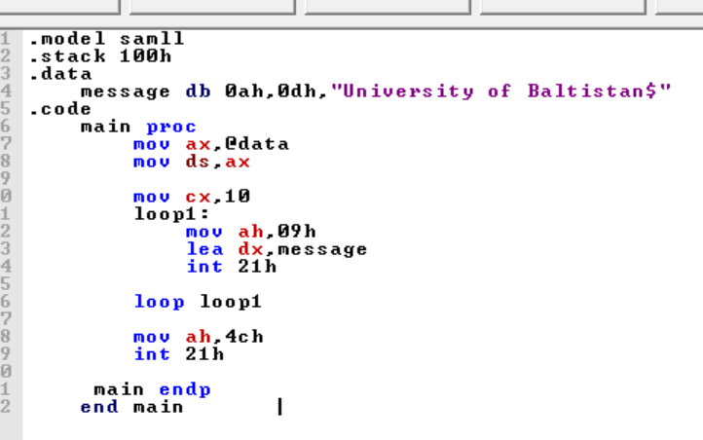

Summary:

In this program we show the string “University” 10 times on the screen, so we used cx register in this program because this program we used loop. The purpose of cx register is just for counting. This program shows the message 10 times because we assign the 10 in cx register and the function is done by using loop.

Output of the Program:

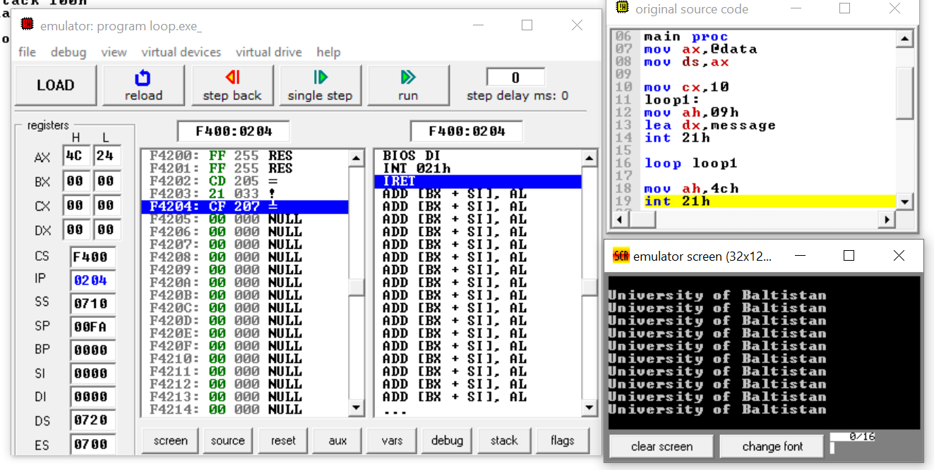

Lab Task 07

Print 0 to 9 number with the help of iteration or loop

Program:

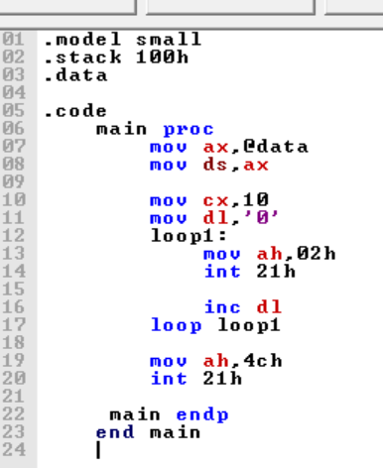

Summary:

In this program we show the numbers from 0 to 10 on the screen, so we used cx register in this program because this program we used loop.

Output of the Program:

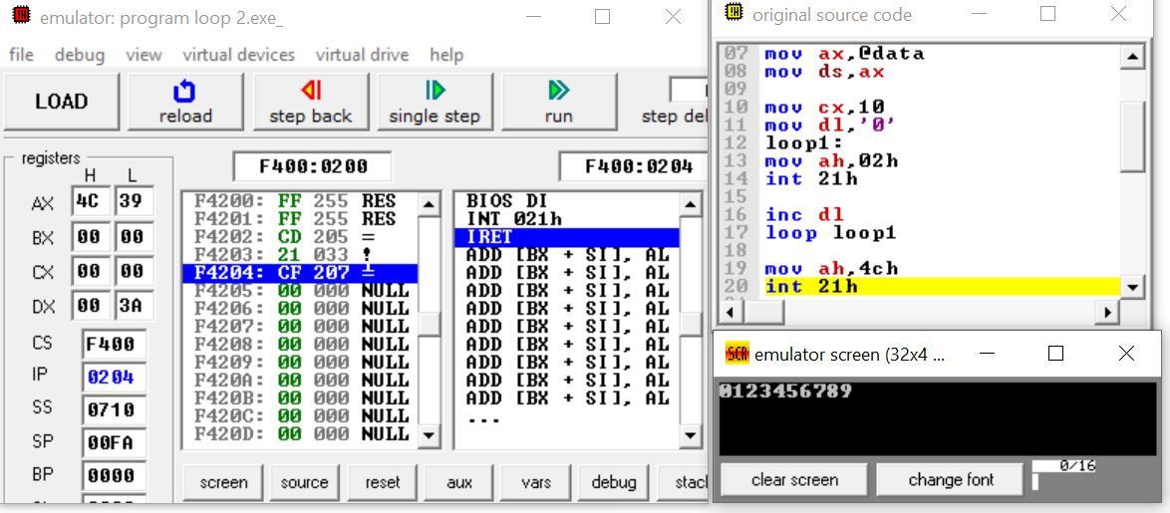

Lab Task 08

Write an assembly program about an array.

Program:

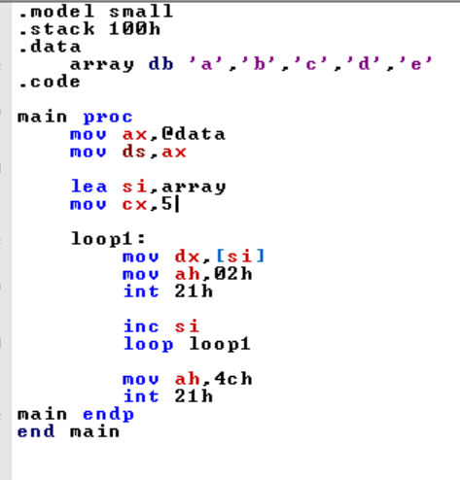

Summary:

This program we declare array which name is array and initially a, b, c, d, e in array we used source index and we used loop and display the values one by one and at end the program exit.

Output of the Program:

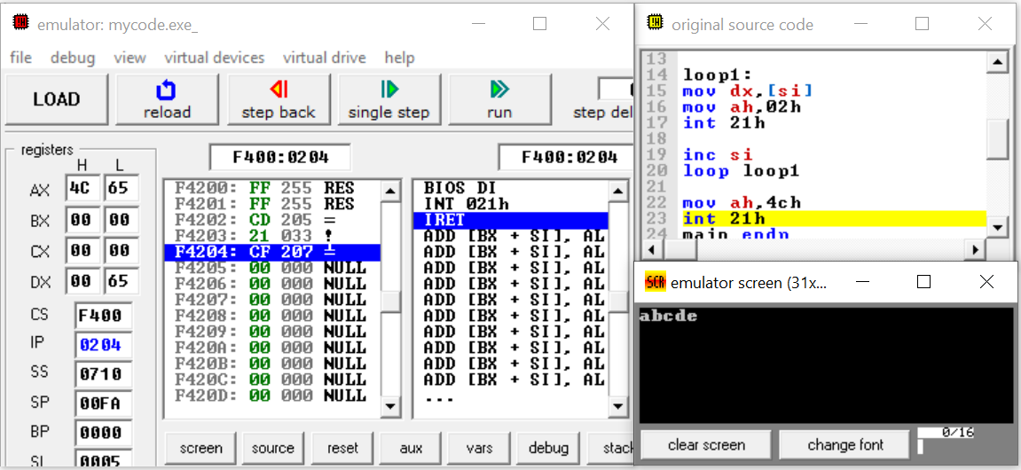

Lab Task 09

Write an assembly program to set your name as a password

Program:

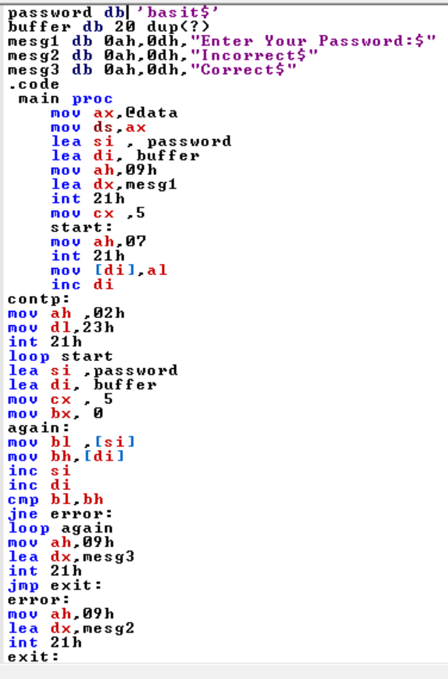

Summary:

This program we declared three variables and assigning some values and first display the prompt for user and takes the password from user and compared those values which is already assigned the variable password. If they are equal the correct password is displayed if not equal incorrect value will have displayed.

Output of the Program:

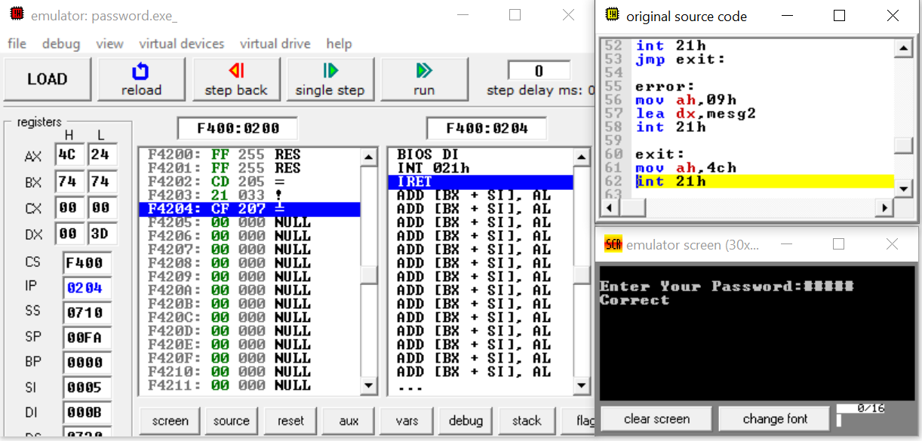

Lab Task 10

Write an assembly program to half pyramid using nested loop up to down

Program:

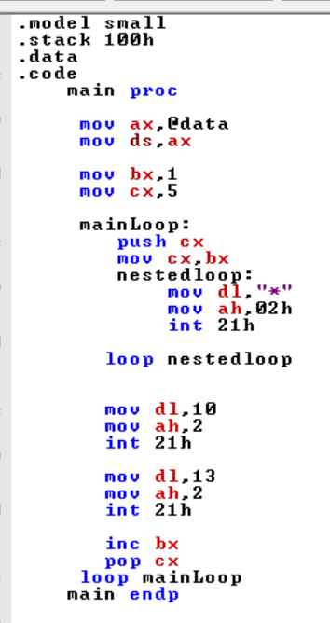

Summary:

In this programs we show the pyramid shape on the screen, so we used cx register in this program because this program we used nested-loop

Output of the Program:

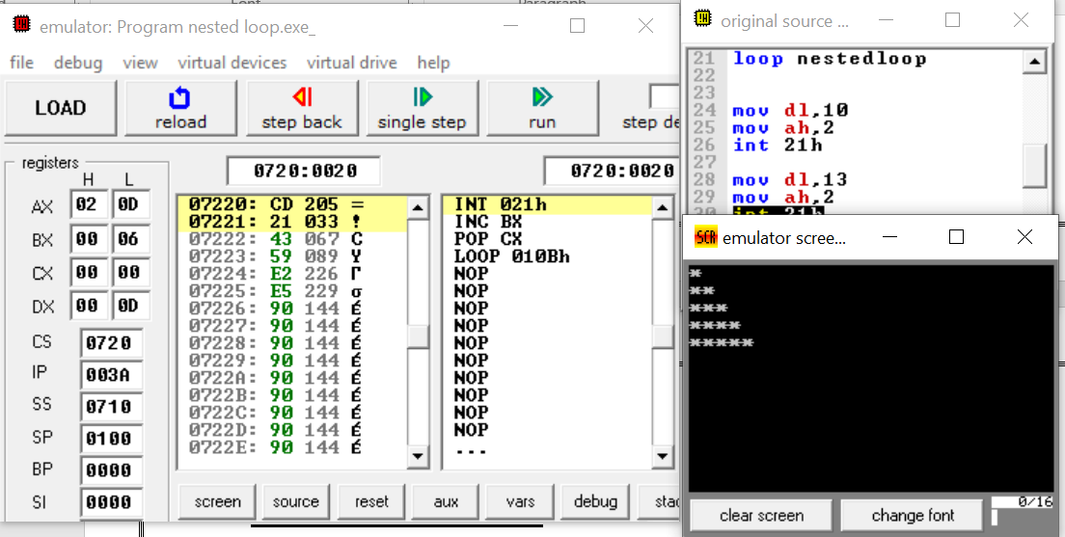

Lab Task 11

Write an assembly program to half pyramid using nested loop down to up

Program:

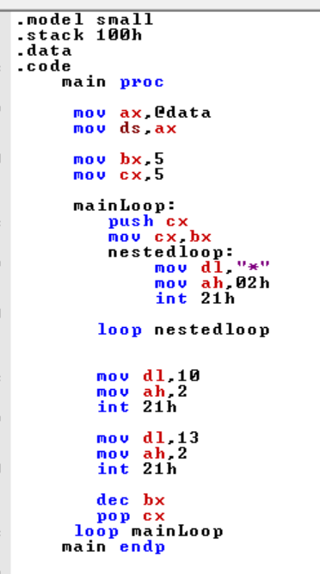

Summary:

In this programs we show the pyramid shape on the screen, so we used cx register in this program because this program we used nested-loop

Output of the Program:

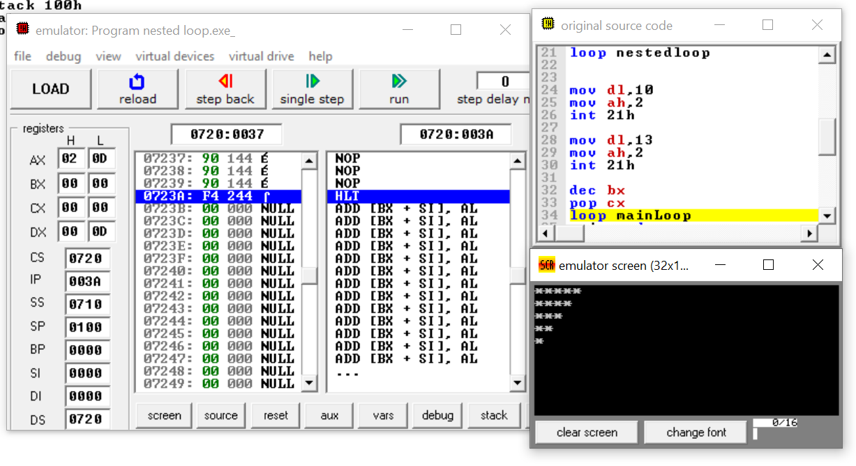

Lab Task 12

Write a program that convert a upper case into a lower case

Program:

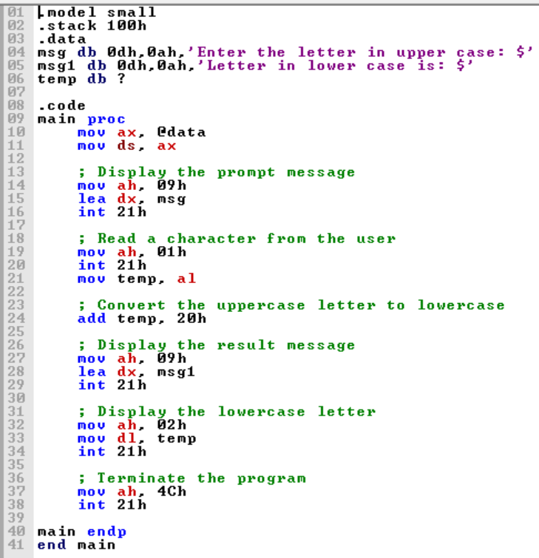

Summary:

In this program, we take a single character in a lower case and convert it into the upper case

Output of the Program:

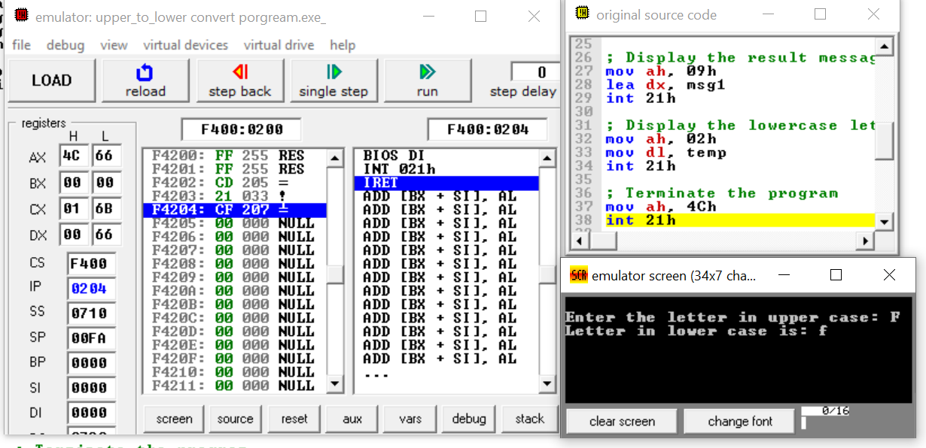

Lab Task 13

Write a program that convert a lower case into an upper case

Program:

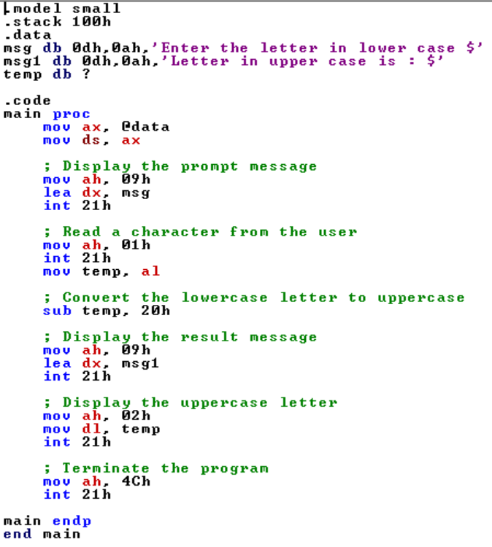

Summary:

In this program, we take a single character in a lower case and convert it into the upper case

Output of the Program:

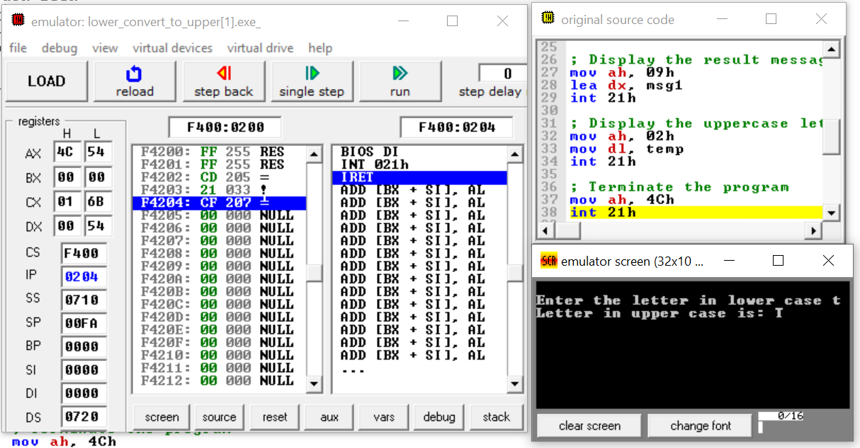

Lab Task 14

Write a program that perform the concept of nested loop in Assembly language

Program:

l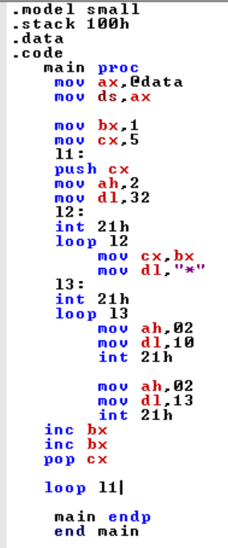

Output of the Program: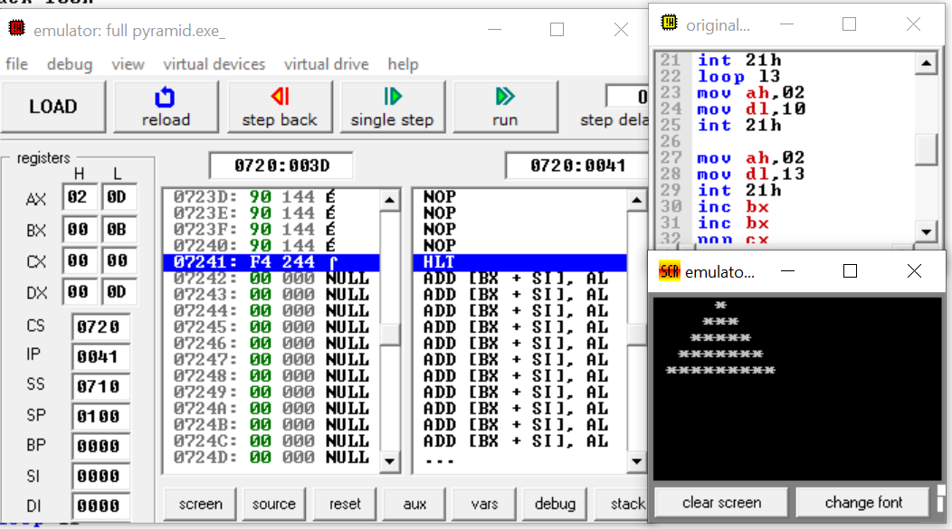

Lab Task 15

Write a program that print reversed name by using the concept of stack in Assembly language

Program:

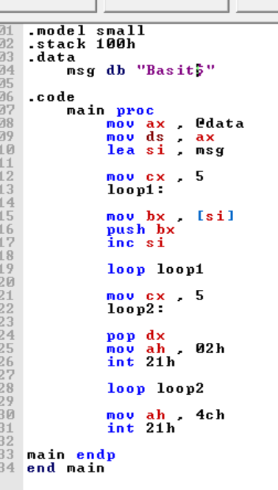

Summary:

In this program, we print our name in the reversed order by using the concept of stack in an assembly language

Output of the Program:

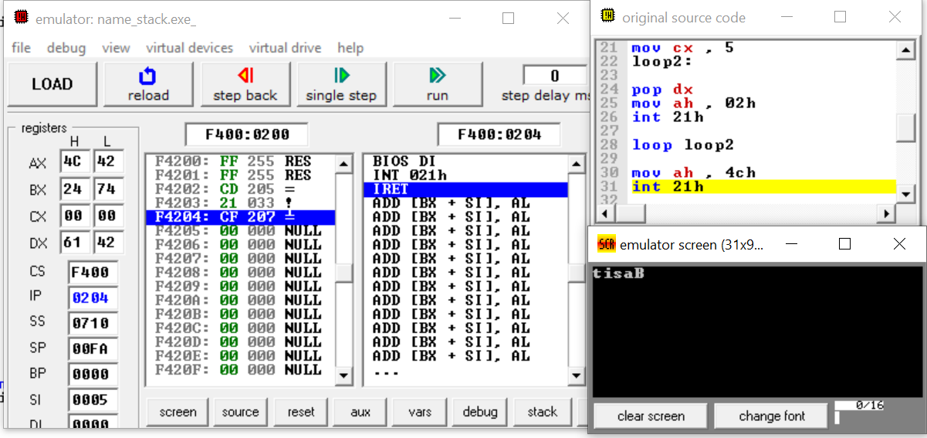

Lab Task 16

Write an assembly program to make a user define procedure by using assembly language

Program:

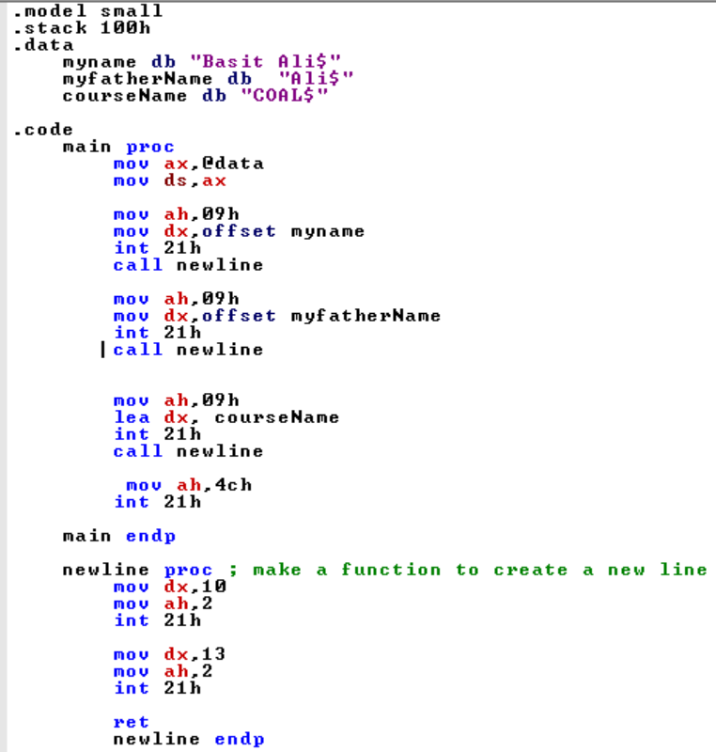

Summary:

In this program, we make a user define function or procedure of newline. The function work when string print then it takes next line for the coming string

Output of the Program:

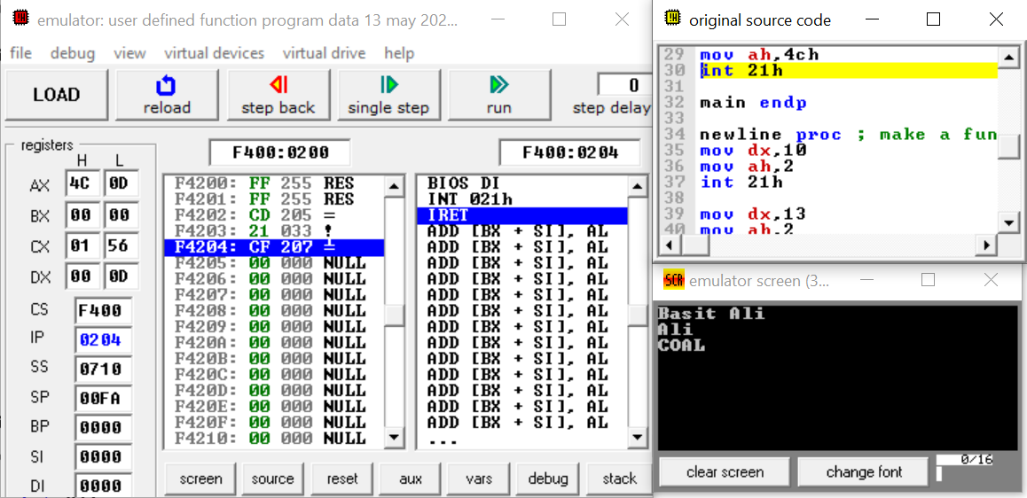

Lab Task 17

Write an assembly program using macro

Program:

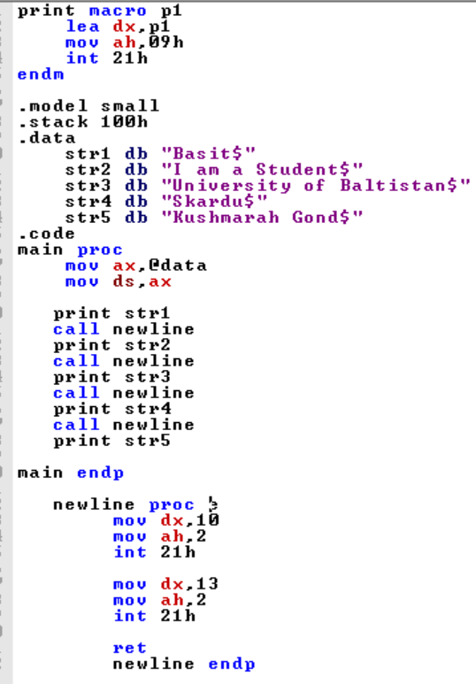

Summary:

In this program, we concise our program by using the macro if don’t use it then our program may be long because we don’t require to store effective address therefore it is helpful for concise to the program

Output of the Program:

